APH201
Coursework 2

NAME: Yongbo Xia
ID NUMBER: 2255161

1.Result:
Question 1: Listings, Tables and Figures.
(a)
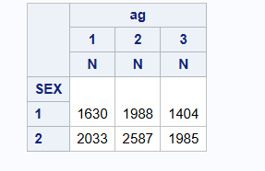
(b)
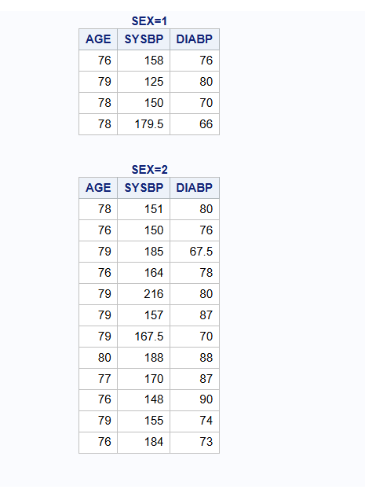

(c)
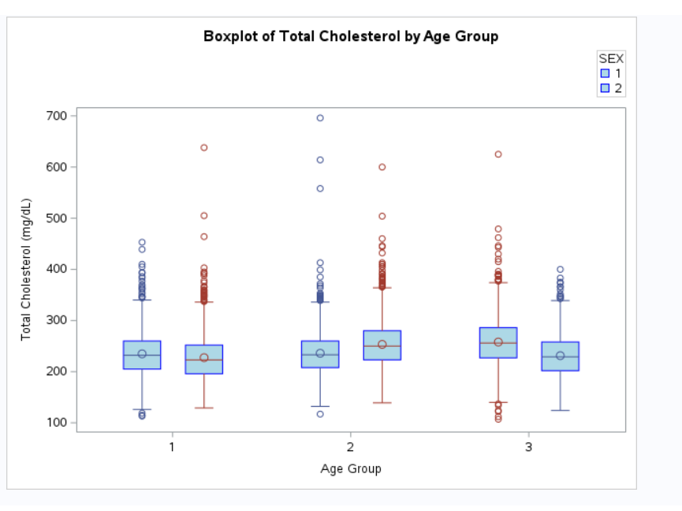
Question 2: Summary Statistics.
(a)
Q2(a).pdf
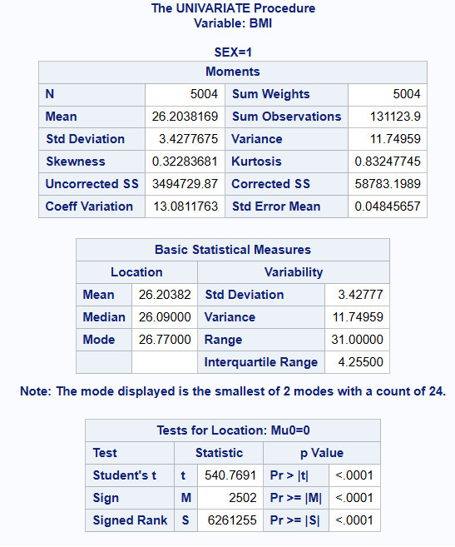
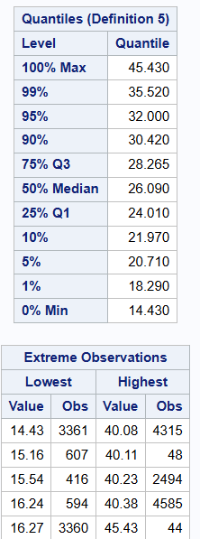
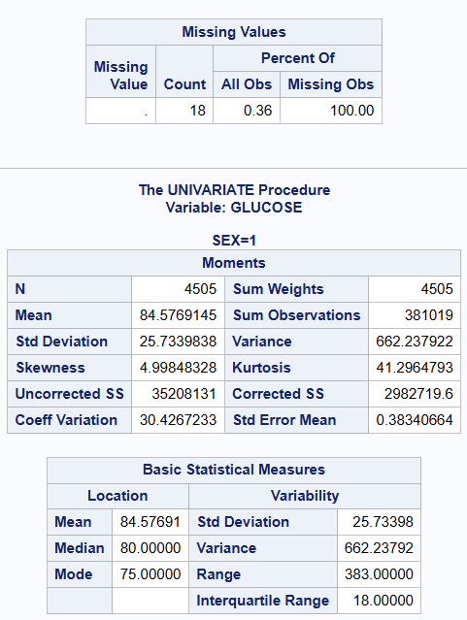
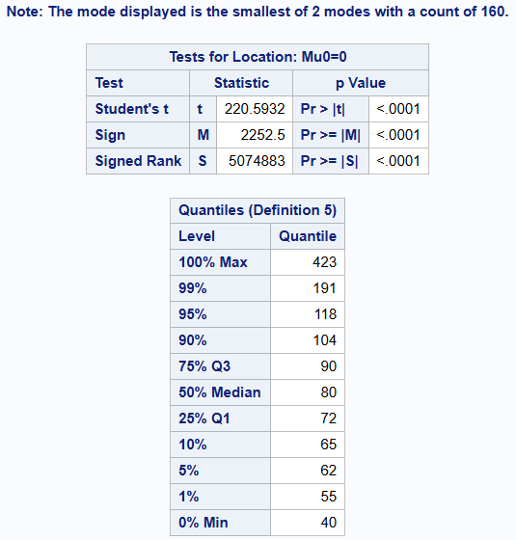

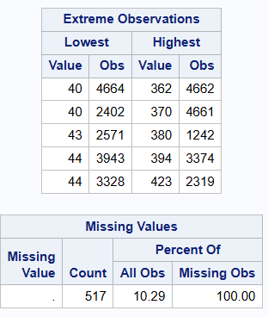
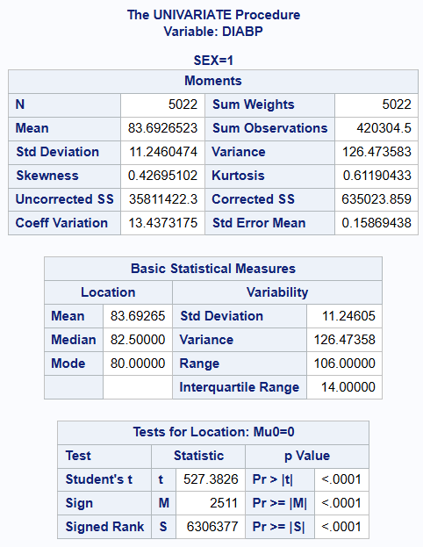
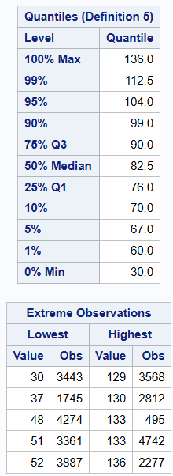
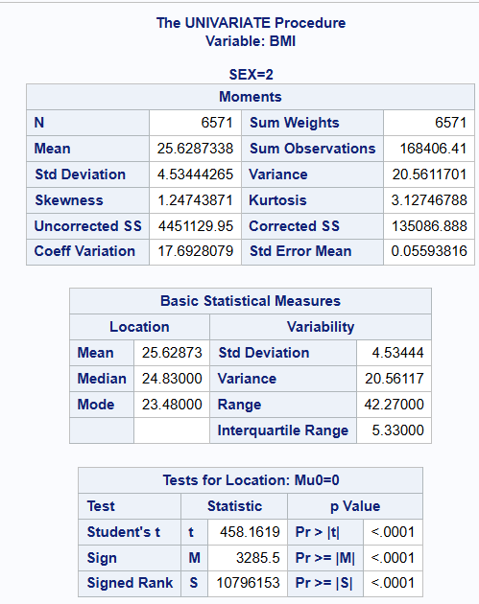
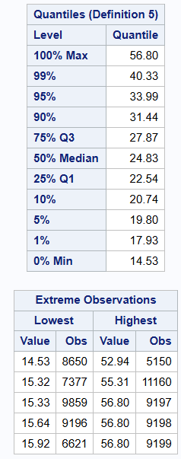
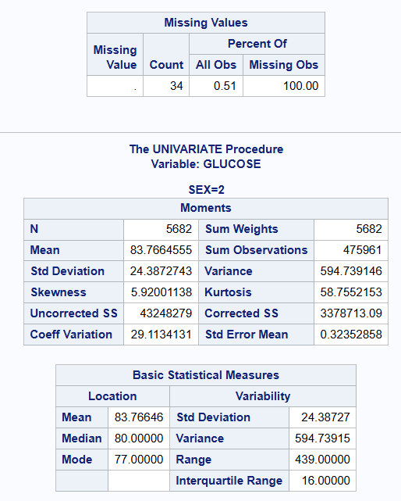
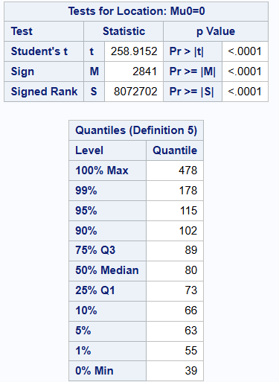
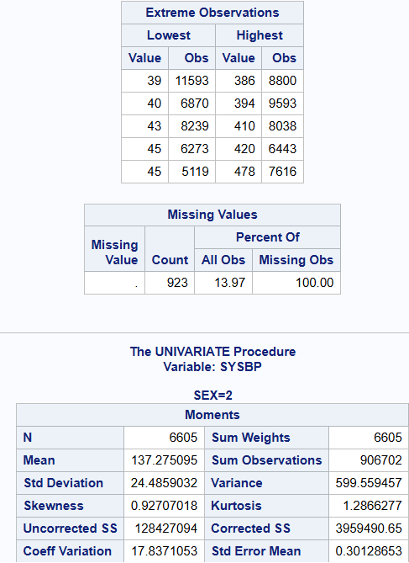
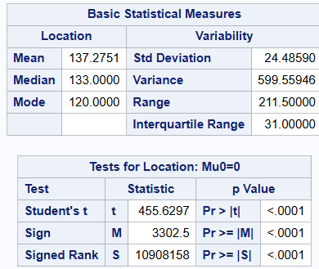
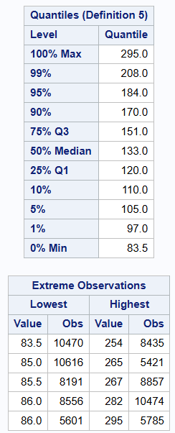
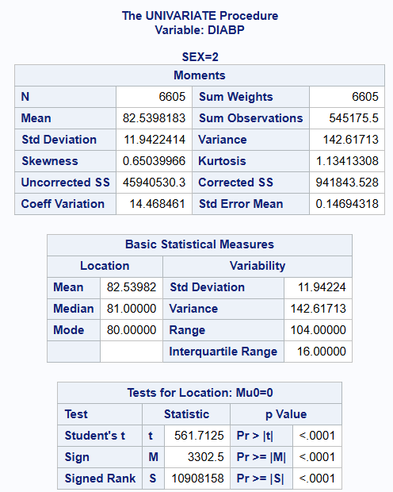

(b)
Q2(b).pdf
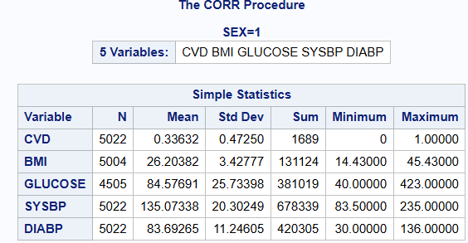
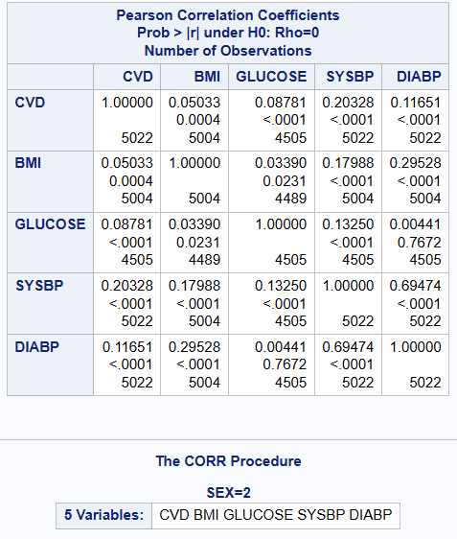
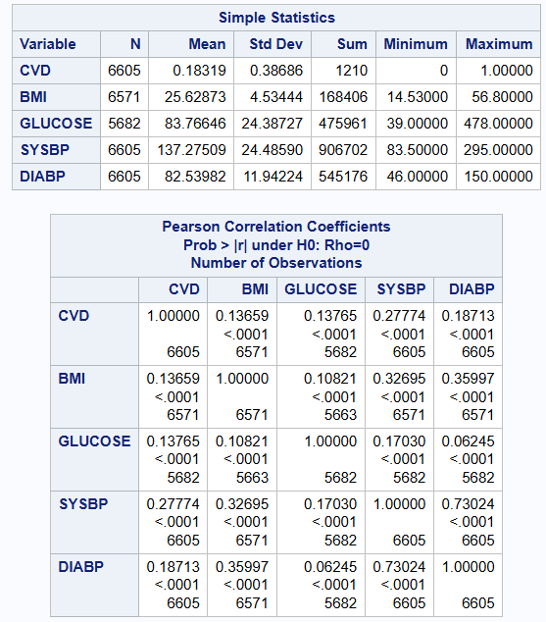
Question 3: Hypothesis Testing.
(a)
Q3(a).pdf
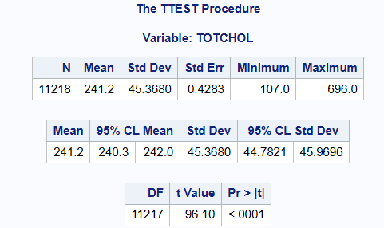
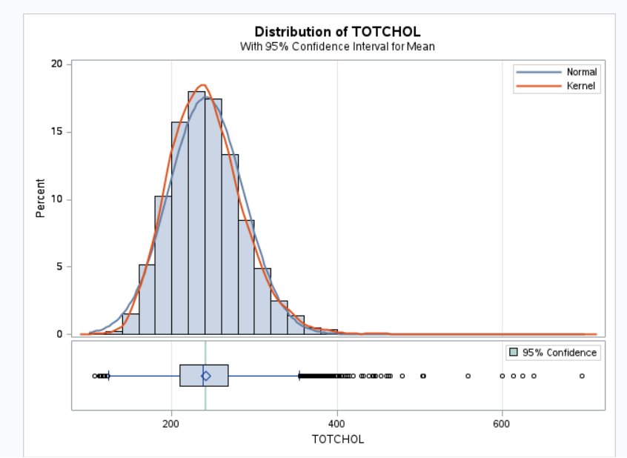
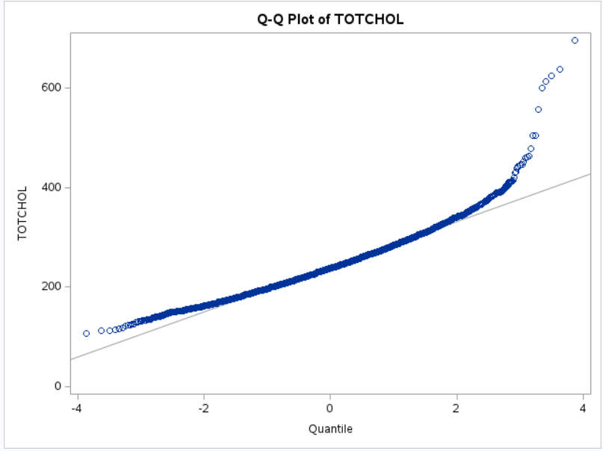

First we define the null hypothesis (H0) and the alternative hypothesis (H1):
•H0=The mean of serum total cholesterol (TOTCHOL) in the sample was not significantly different from the standard body cholesterol level (200 mg/dL).
•H1=The mean of serum total cholesterol (TOTCHOL) in the sample was significantly different from the standard body cholesterol level (200 mg/dL).

According to SAS output:
•The T value = 96.10 corresponds to a p-value less than 0.0001.
•The mean of total serum cholesterol (TOTCHOL) in the samples was 241.2 mg/dL.
•The 95% sample mean confidence interval is 240.3 to 242.0 mg/dL, so at the 95% confidence level, the sample mean falls within this interval.
Result:
•The sample mean of 241.2 mg/dL was significantly higher than the standard body cholesterol level of 200 mg/dL.
•The p-value is less than 0.0001.
•So the null hypothesis can be rejected, the mean of serum total cholesterol (TOTCHOL) in the sample was significantly different from the standard body cholesterol level (200 mg/dL).

(b)
Q3(b).pdf
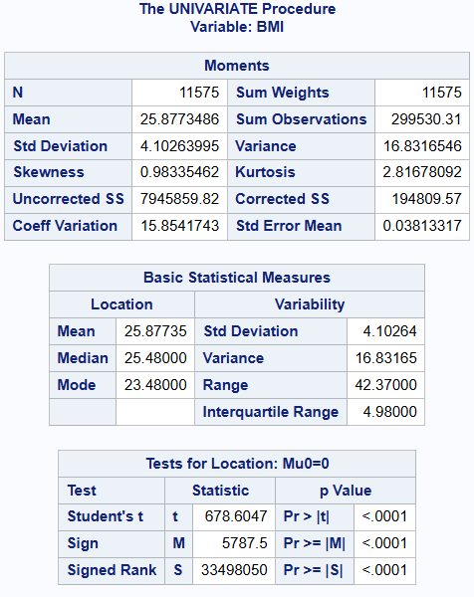
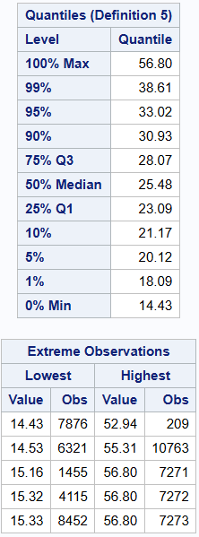
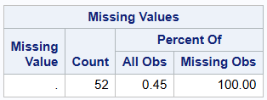
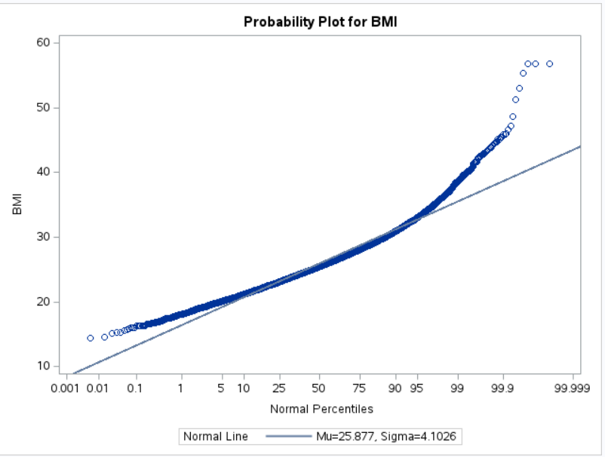
•Skewness: The skewness value is 0.98335462, the value suggests a slight positive skewness.
•Kurtosis: The kurtosis value is 2.81678092, the value is slightly above 3, suggesting a slightly leptokurtic distribution, which has a more peaked shape than a normal distribution.
•Probability plot: The probability plot compares the quantile of the BMI data to the quantile of the normal distribution, and the points on the plot coincide with the normal line.
•Result: BMI is approximately a normal distribution.

(c)
Q3(c).pdf
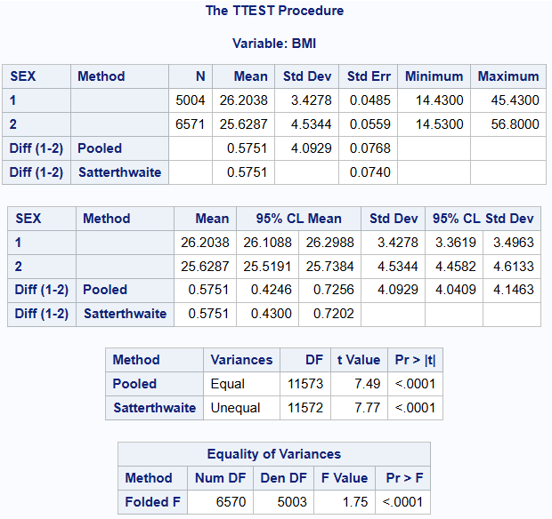
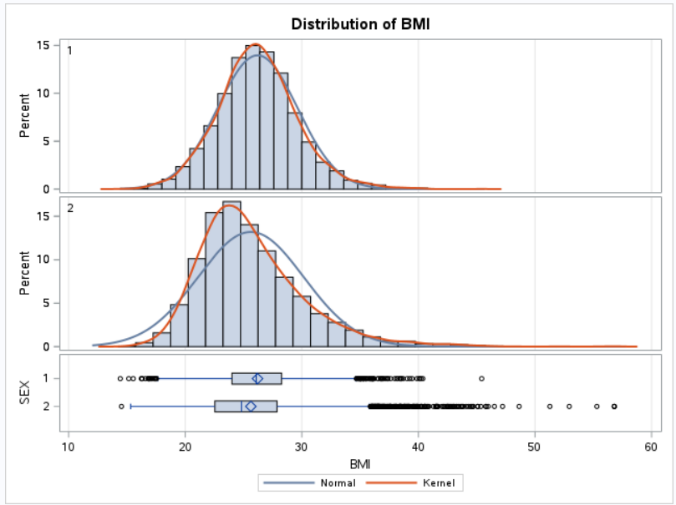
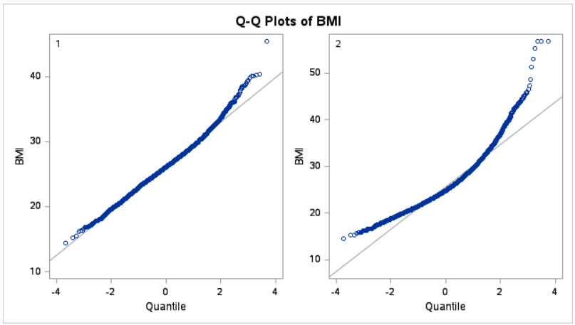
Group 1 (male):
Sample size: 5004 Mean: 26.2038 Standard deviation: 3.4278
Minimum value: 14.4300 Maximum value: 45.4300
Group 2 (female):
Sample size: 6571 Mean: 25.6287 Standard deviation (Std Dev): 4.5344
Minimum value: 14.5300 Maximum value: 56.8000
Two-sample T test
•Pooled method:
Suppose the variance of the two samples is equal.
The calculated T-value is 7.49. A P-value of less than 0.0001 indicates a statistically significant difference in mean BMI between the two sex groups.
•Satterthwaite method:
The degrees of freedom are adjusted using the Satterthwaite formula without assuming that the variances of the two samples are equal.
The calculated T-value is 7.77.
The P-value is also less than 0.0001, indicating a statistically significant difference in mean BMI between the two sex groups.
•Equality of Variances
- value of 1.75 and a P-value less than 0.0001, indicates a statistically significant difference in variance between the two sex groups.
Result:
In conclusion, there was a significant difference in mean BMI between the two sex groups.

(d)
Q3(d).pdf
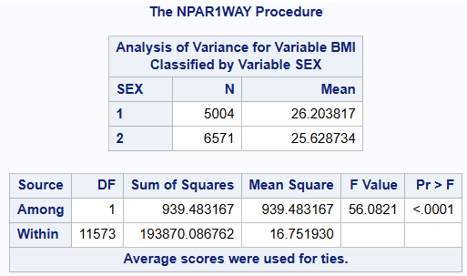
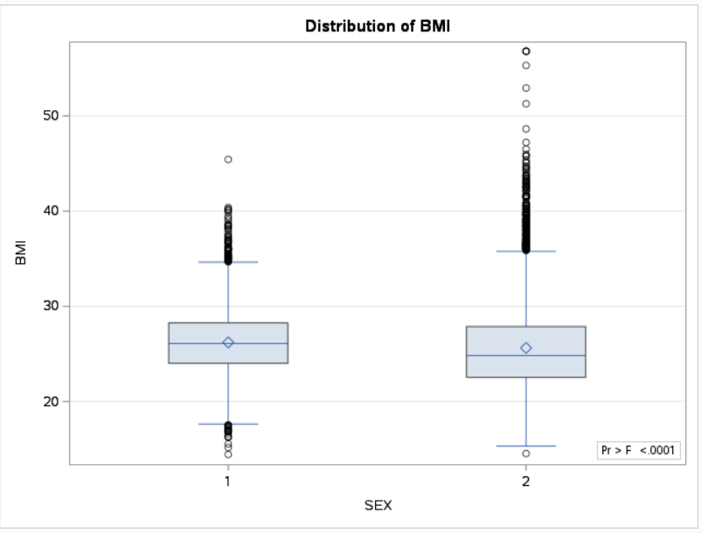
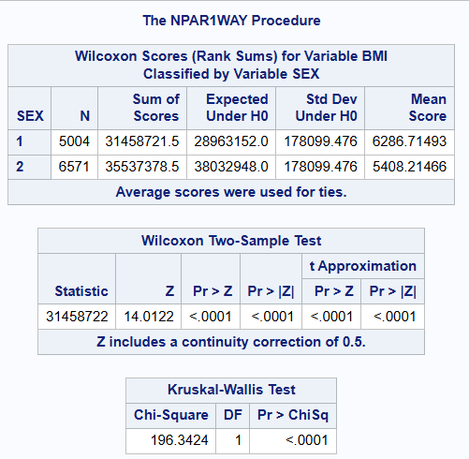
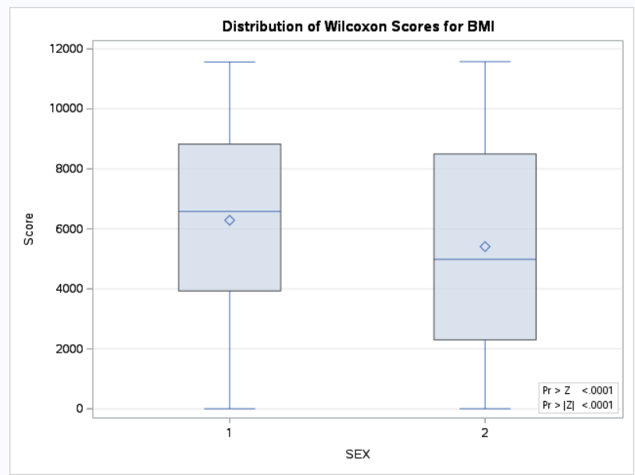
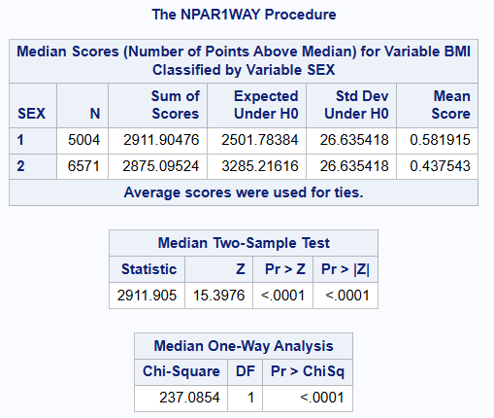
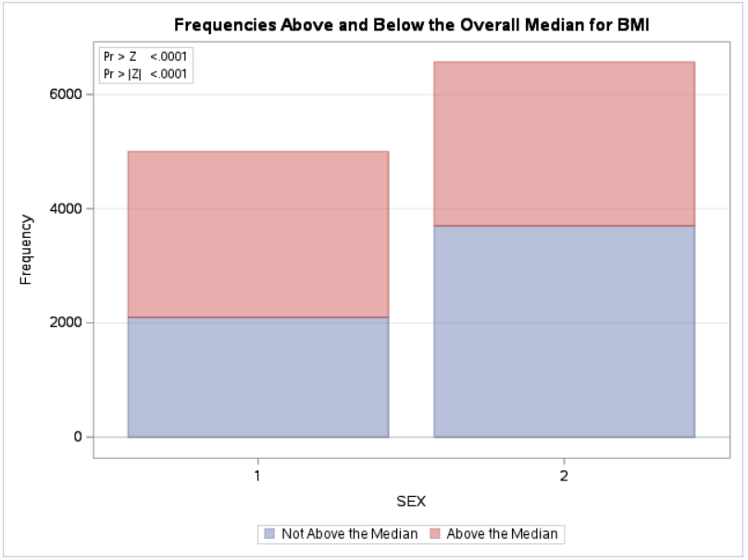
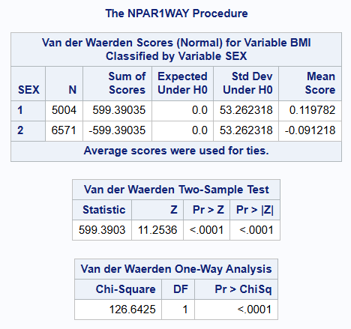
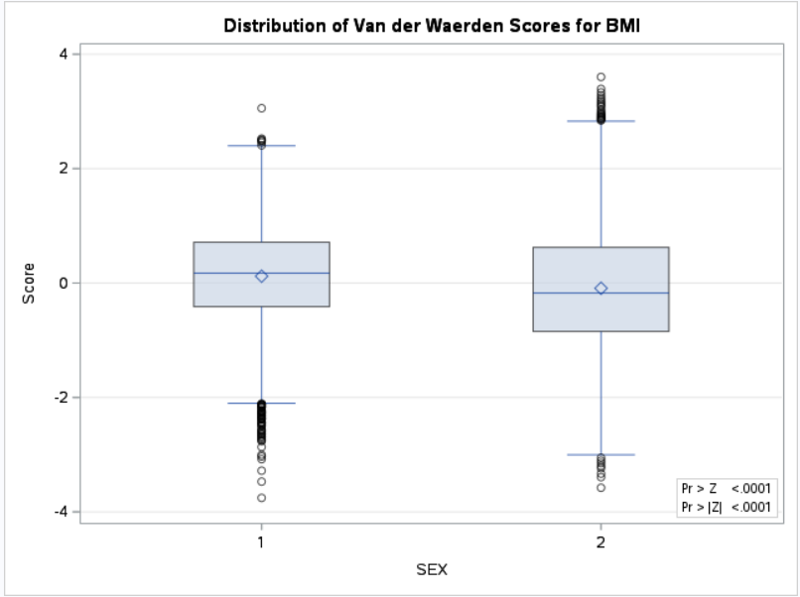
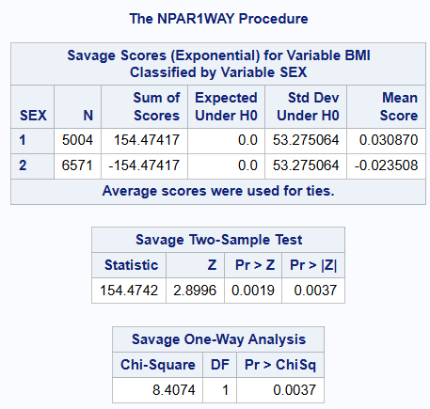
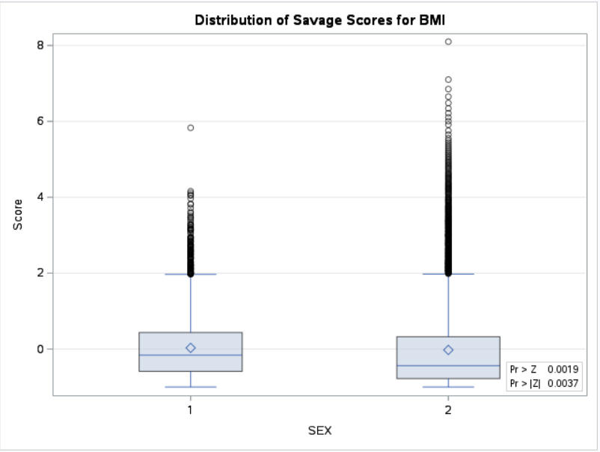
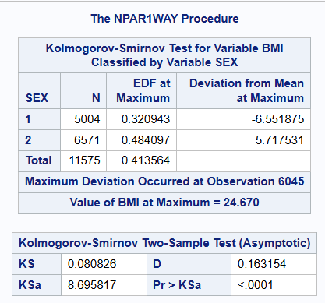
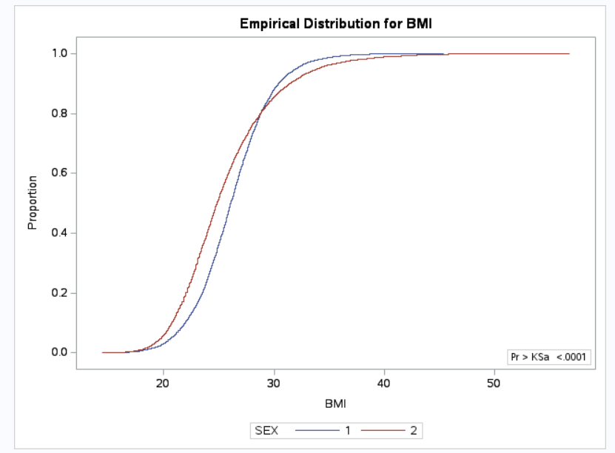
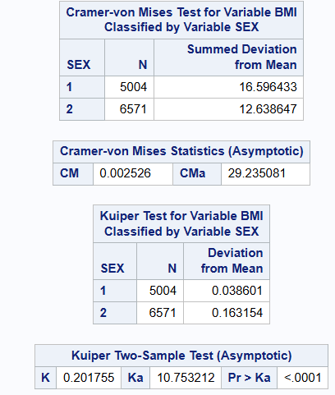
The Z-value of the Wilcoxon rank sum test is 14.0122, and the corresponding p-value is less than 0.0001. Since the P-value is much smaller than commonly used significance levels (such as 0.05 or 0.01), we can reject the null hypothesis that there is a significant difference in mean BMI between the two sex groups.
Therefore, based on the results of the Wilcoxon-Mann-Whitney test, we can conclude that there is a significant difference in mean BMI between the two sex groups.

Question 4: Regression
(a)
Q4(a).pdf
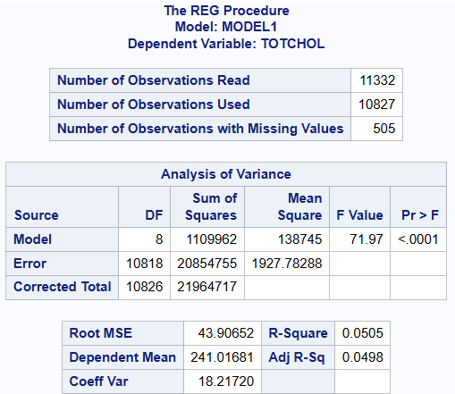
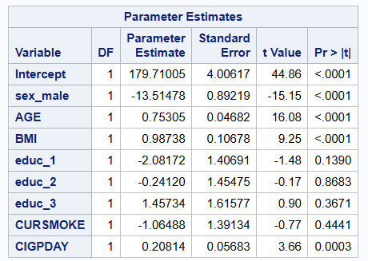
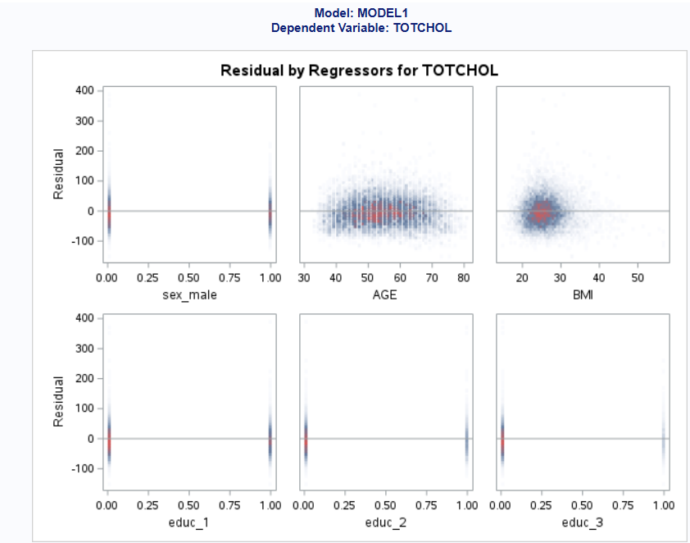
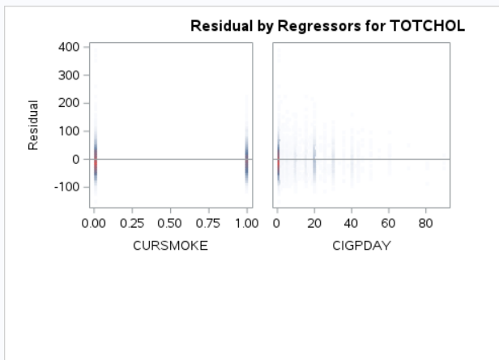
(b)
Q4(b).pdf
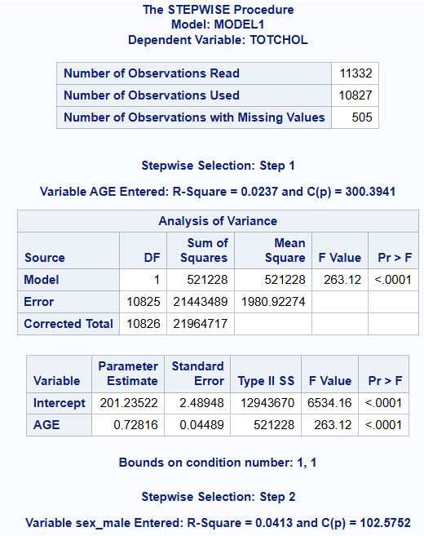
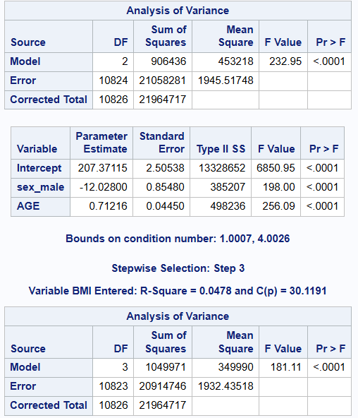
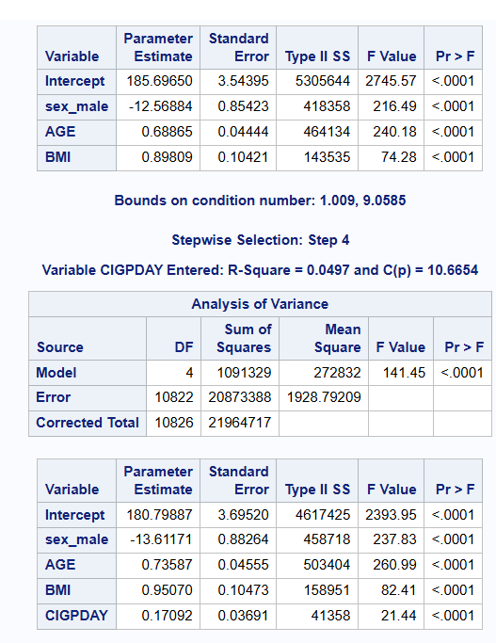
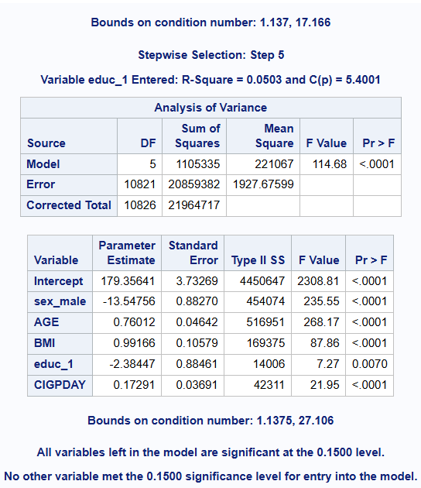
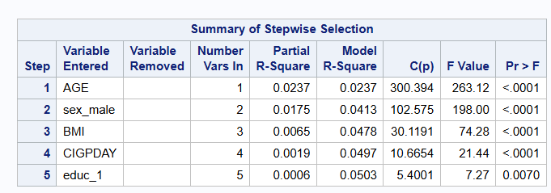
Question 5: Logistic regression.
(a)
Q5(a).pdf
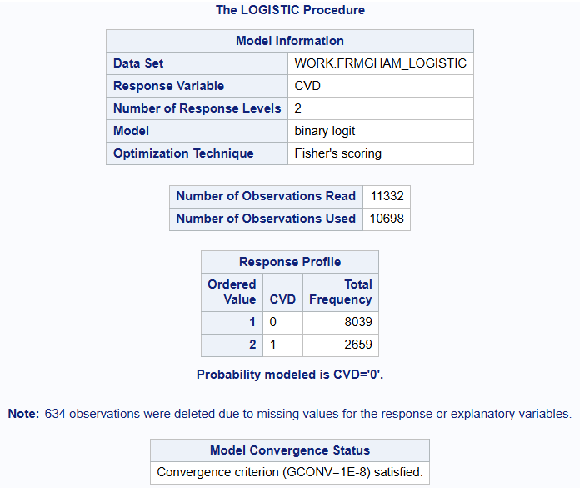
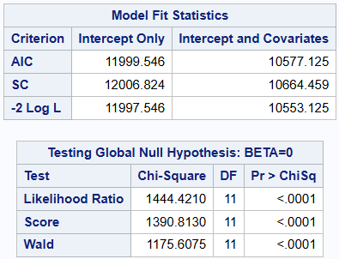
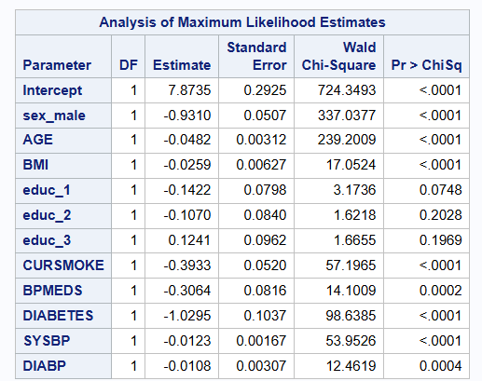
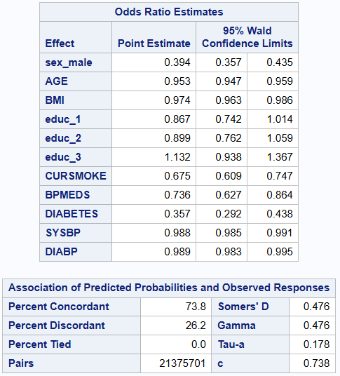
(b)
Q5(b).pdf
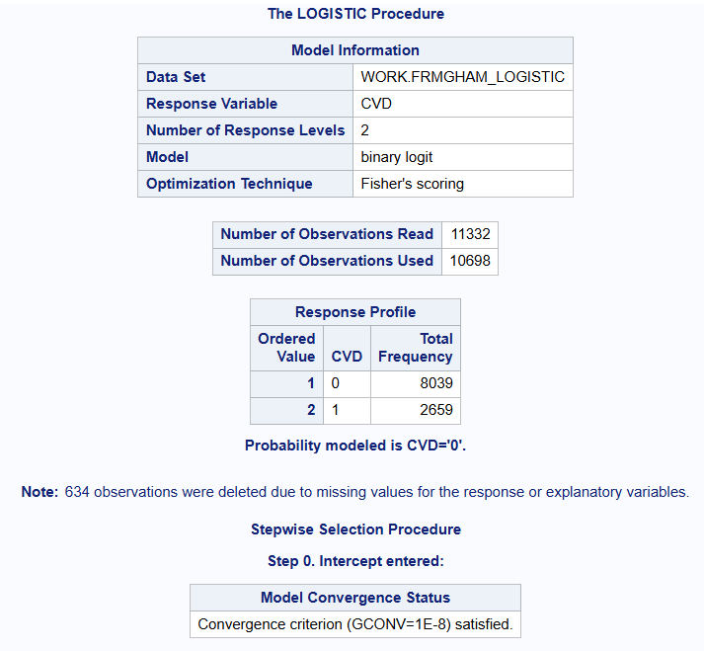
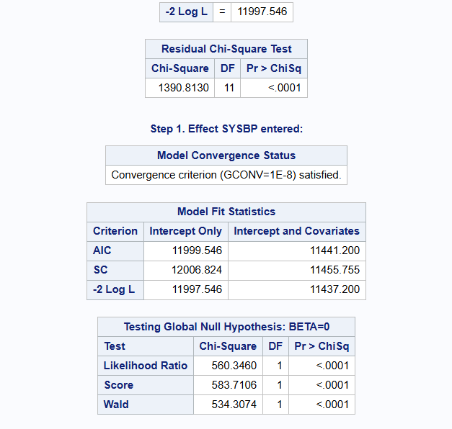
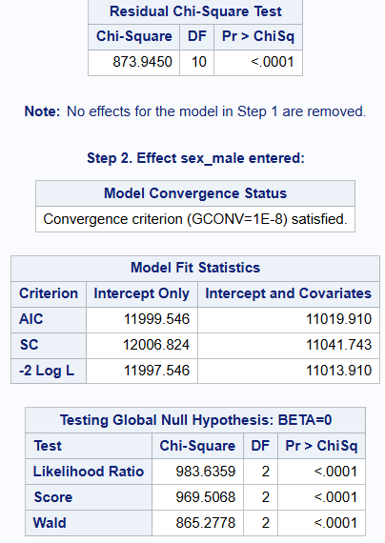
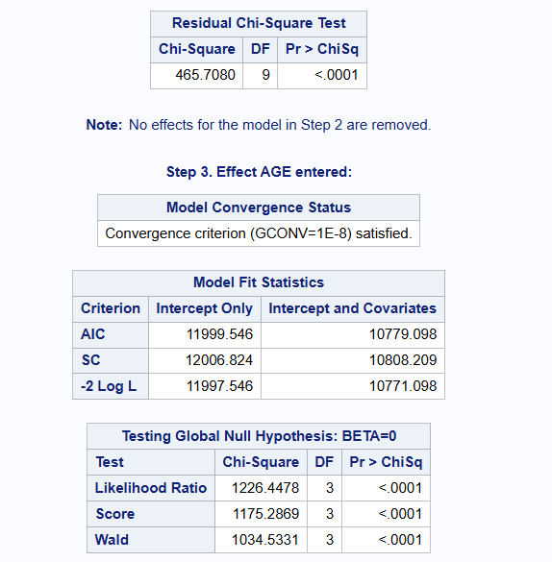
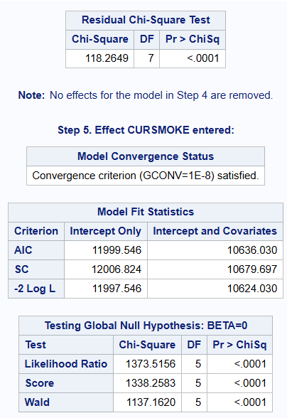
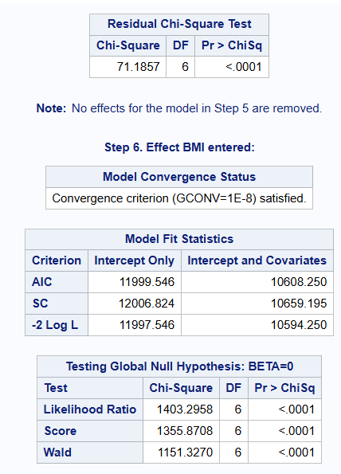
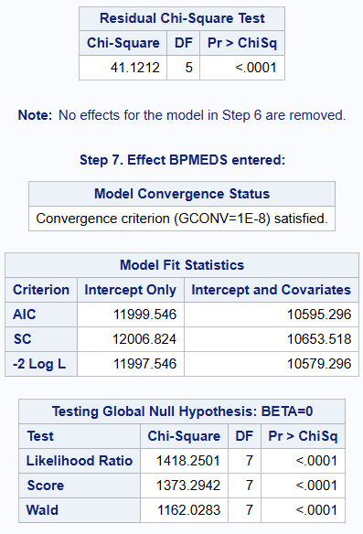
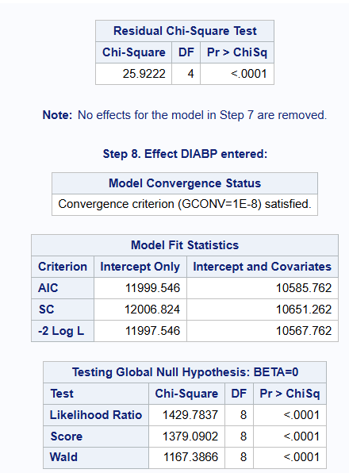
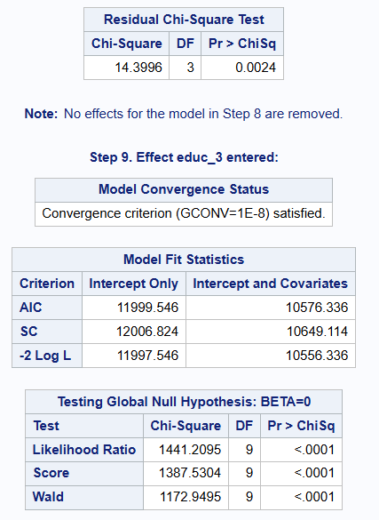
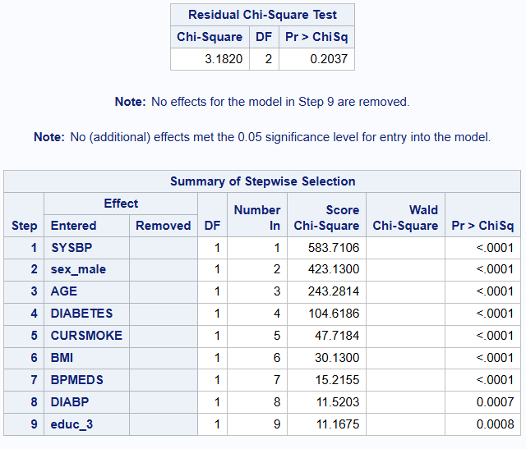
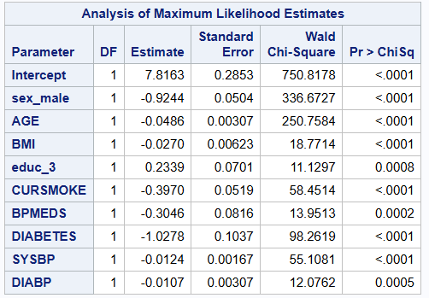
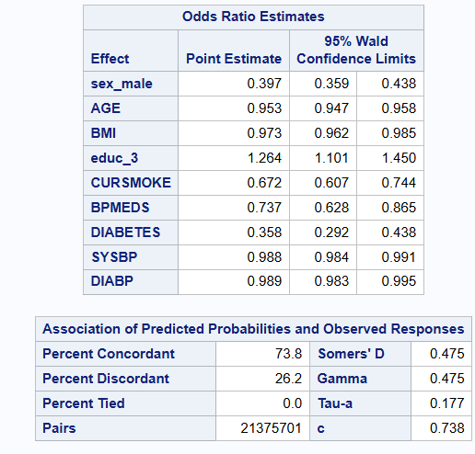

(c)
Q5(c).pdf
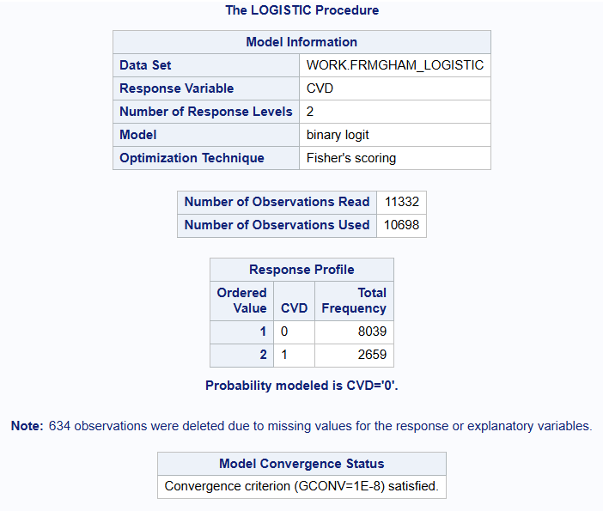
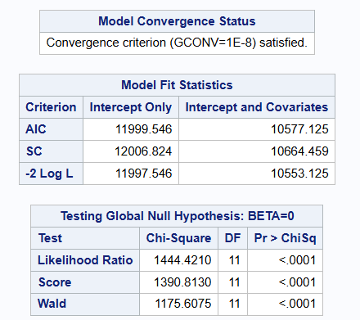

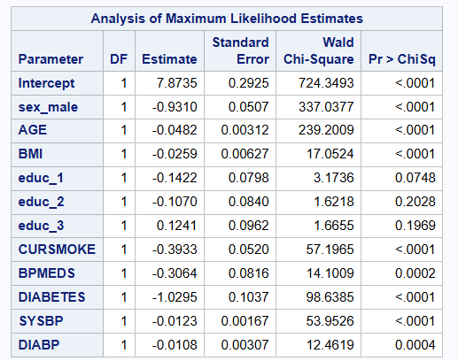
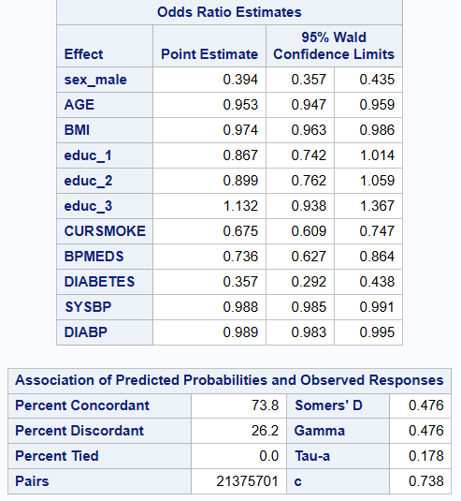
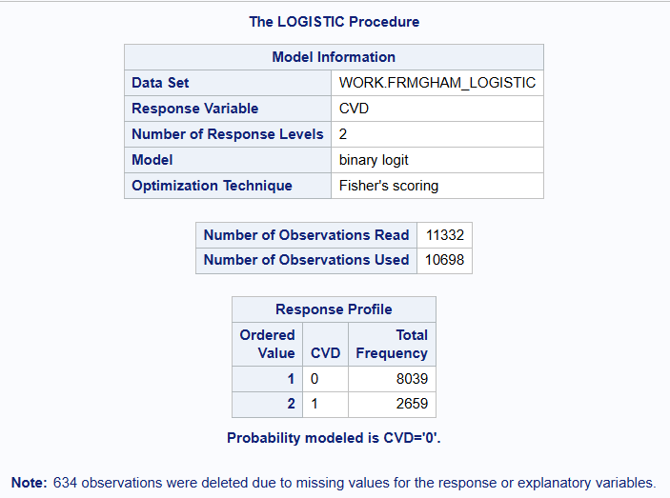
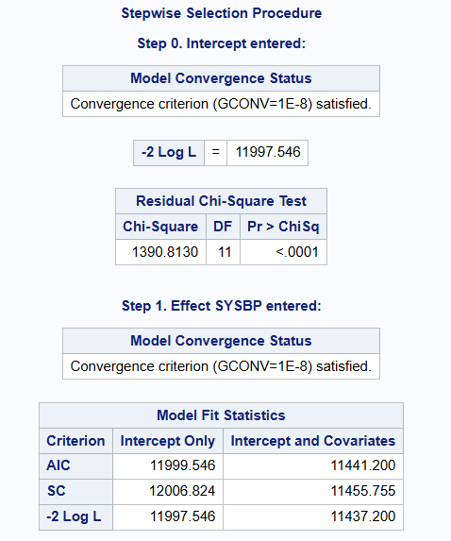
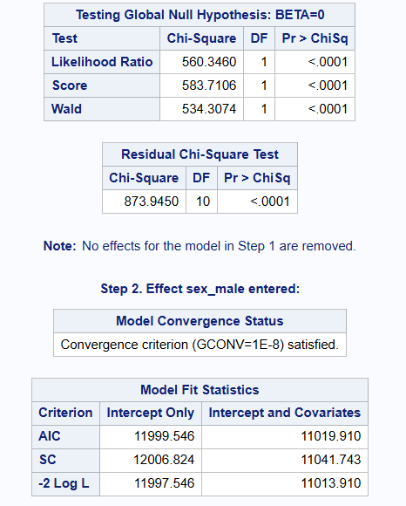
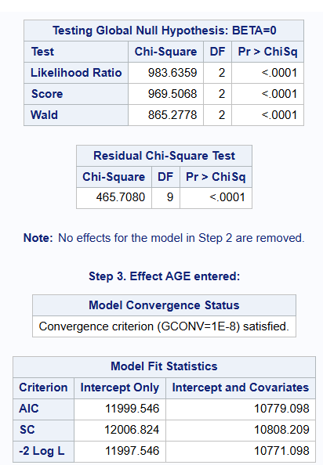
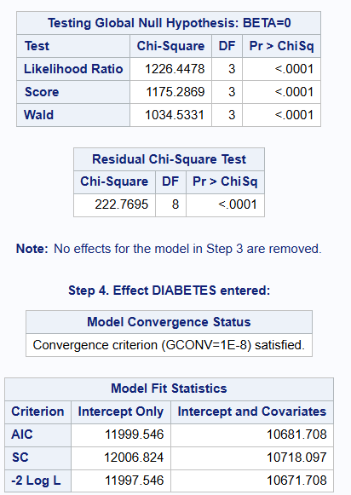
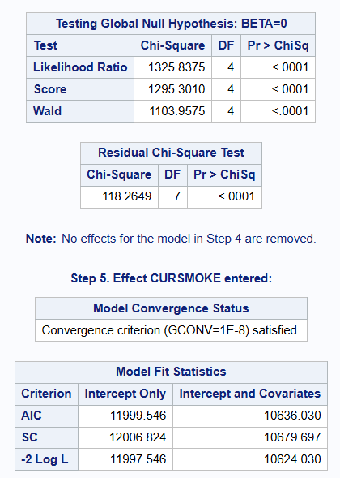
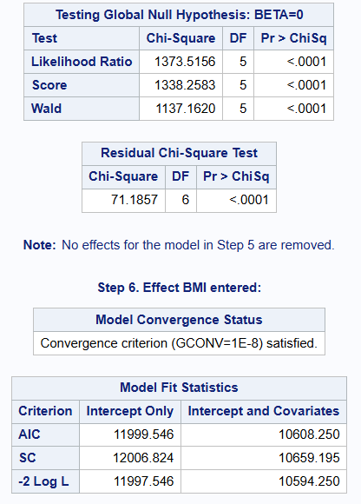
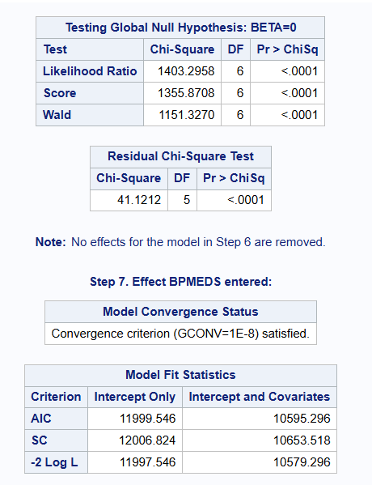
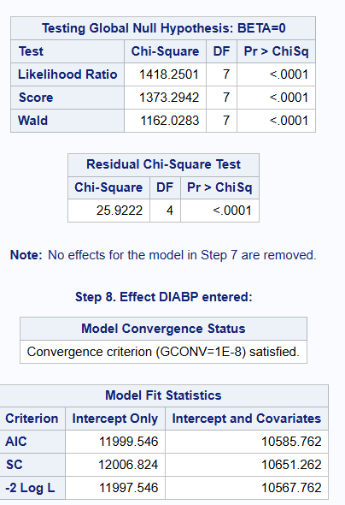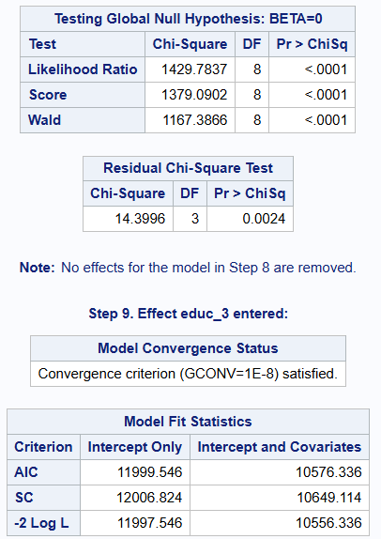
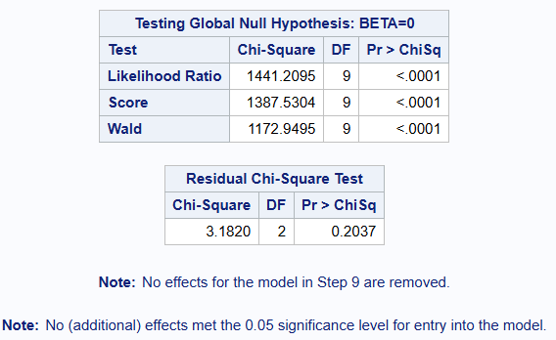
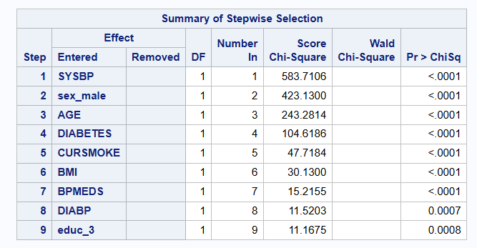
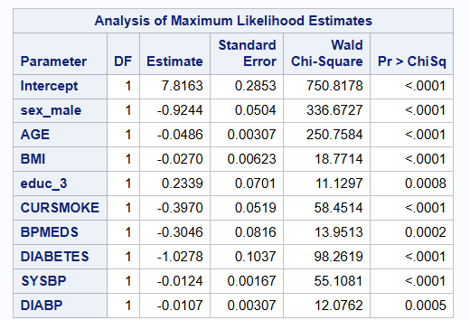
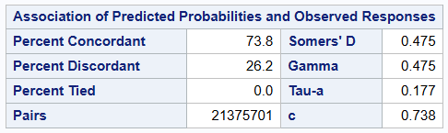
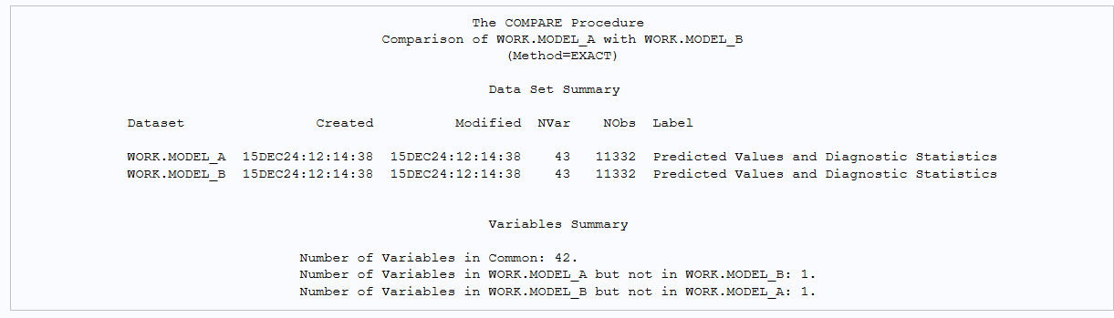
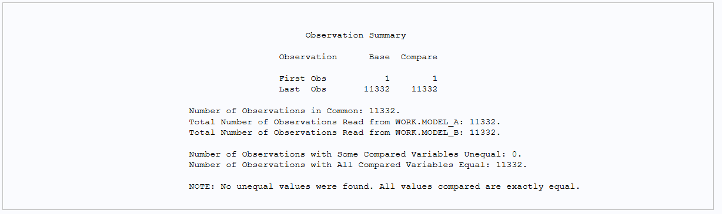
Stepwise Selection Model
•Model Fit Statistics:
The final model obtained after the stepwise selection procedure shows improvements in criteria such as the Akaike Information Criterion (AIC) and Schwarz Criterion (SC), which decreased from their intercept-only values of 11999.546 and 12006.824, respectively, to 10576.336 and 10649.114 for the AIC and SC of the final model.
The -2 Log Likelihood value also improved, decreasing from 11997.546 for the intercept-only model to 10556.336 for the final model.
•Variable Inclusion and Significance:
Variables included in the final model, in order of their entry, are SYSBP, sex_male, AGE, DIABETES, CURSMOKE, BMI, BPMEDS, DIABP, and educ_3.
Each variable's entry was statistically significant, as indicated by the likelihood ratio, score, and Wald chi-square test results, all with p-values less than 0.0001, except for DIABP and educ_3, which entered with p-values of 0.0007 and 0.0008, respectively.
•Parameter Estimates and Odds Ratios:
The final model provides estimates for the intercept and each included variable, along with their standard errors, chi-square statistics, and p-values.
Odds ratios and their 95% confidence intervals are also provided, allowing for the interpretation of the association between each explanatory variable and the response variable (CVD).
•Predictive Performance:
The model's predictive performance is evaluated through measures such as percent concordance (73.8%), Somers' D (0.475), gamma (0.475), and Tau-a (0.177), which assess the agreement between predicted probabilities and observed responses.
Comparison of Predictive Capability and Fitted Values
Predictive Capability: Both models aim to predict the occurrence of CVD. The stepwise selection model likely offers a more parsimonious representation of the data while maintaining predictive power, as indicated by the improvements in AIC, SC, and -2 Log Likelihood.
•Fitted Values:
The final model from the stepwise selection procedure should provide fitted values (predicted probabilities of CVD) that are closer to the observed outcomes, as suggested by the high percent concordance and other association measures.
Result
The stepwise selection model is a better fit for predicting CVD.

(d)
Q5(d).pdf
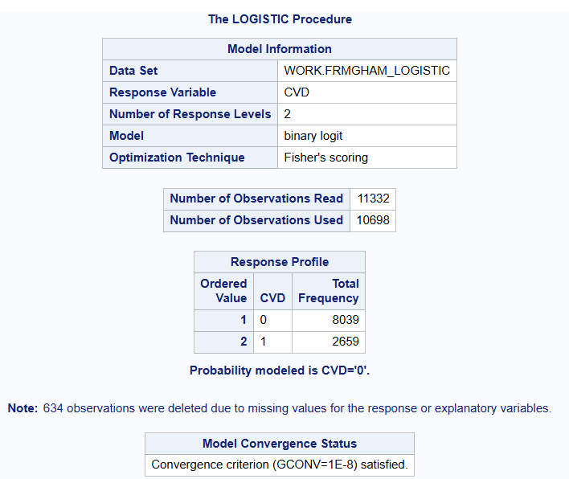
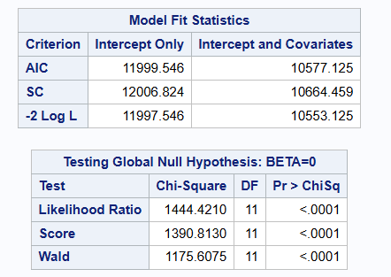
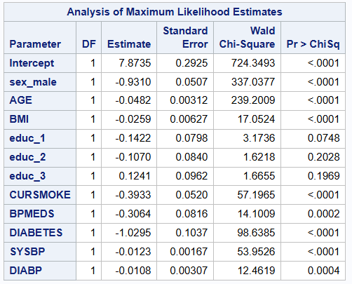
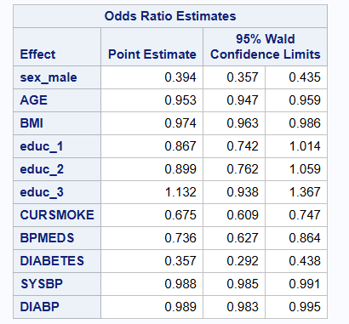
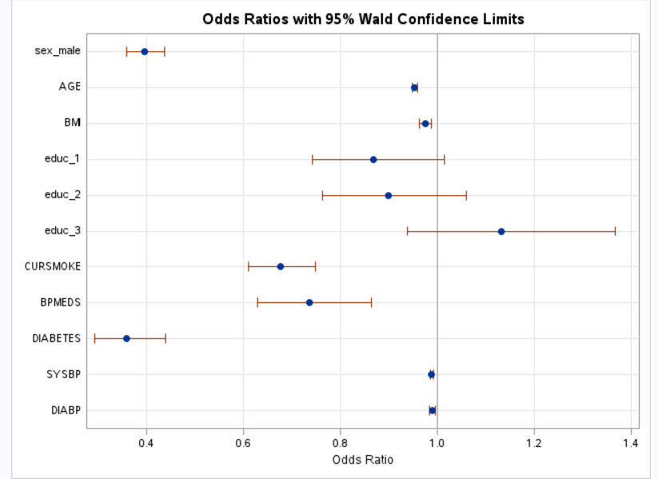
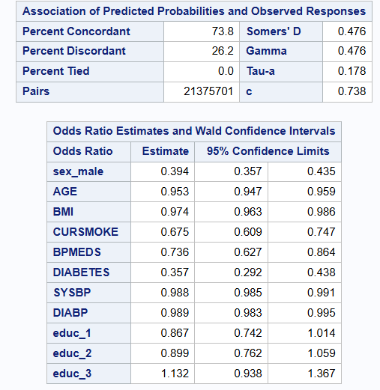
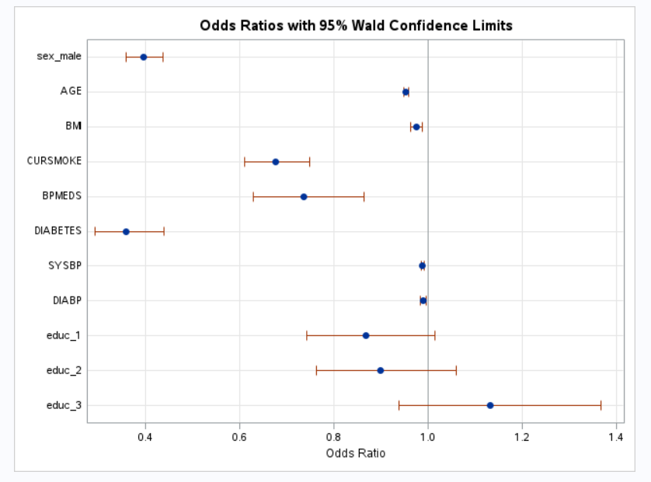
Here are the odds ratios (along with their 95% confidence intervals) for all the variables related to CVD based on the model, along with an indication of which ones are significant (P-value < 0.05):
sex_male:
Odds Ratio: 0.394
95% Confidence Interval: 0.357, 0.435
Significant (P-value < 0.0001)
AGE:
Odds Ratio: 0.953
95% Confidence Interval: 0.947, 0.959
Significant (P-value < 0.0001)
BMI:
Odds Ratio: 0.974
95% Confidence Interval: 0.963, 0.986
Significant (P-value < 0.0001)
educ_1:
Odds Ratio: 0.867
95% Confidence Interval: 0.742, 1.014
Not Significant (P-value = 0.0748)
educ_2:
Odds Ratio: 0.899
95% Confidence Interval: 0.762, 1.059
Not Significant (P-value = 0.2028)
educ_3:
Odds Ratio: 1.132
95% Confidence Interval: 0.938, 1.367
Not Significant (P-value = 0.1969)
CURSMOKE:
Odds Ratio: 0.675
95% Confidence Interval: 0.609, 0.747
Significant (P-value < 0.0001)
BPMEDS:
Odds Ratio: 0.736
95% Confidence Interval: 0.627, 0.864
Significant (P-value = 0.0002)
DIABETES:
Odds Ratio: 0.357
95% Confidence Interval: 0.292, 0.438
Significant (P-value < 0.0001)
SYSBP:
Odds Ratio: 0.988
95% Confidence Interval: 0.985, 0.991
Significant (P-value < 0.0001)
DIABP:
Odds Ratio: 0.989
95% Confidence Interval: 0.983, 0.995
Significant (P-value = 0.0004)
In conclusion, among these variables, sex_male, AGE, BMI, CURSMOKE, BPMEDS, DIABETES, SYSBP, and DIABP are significant, with P-values less than 0.05. The three education-related variables (educ_1, educ_2, educ_3) are not significant in this model.

- Appendix
Code:
coursework2 code.pdf
